**THIS TEST REQUIRES SIMPLE CODE WITH LOTS OF ERROR CHECKING. DO NOT OVERCOMPLICATE.**

1. Owners Direct Code Challenge - **Shipping Routes**

A shipping company has a network of routes to different ports in the Atlantic Ocean. This network of routes is shown in the following diagram:

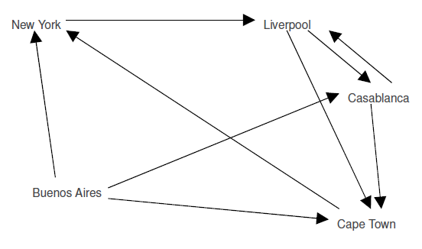

Routes are one way (indicated by the direction of the arrow). The only journey with a direct return is the Liverpool – Casablanca route, indicated by the two arrows. The journey times for the routes are as follows:

Buenos Aires > New York = 6 days

Buenos Aires > Casablanca = 5 days

Buenos Aires > Cape Town = 4 days

New York > Liverpool = 4 days

Liverpool > Casablanca = 3 days

Liverpool > Cape Town = 6 days

Casablanca > Liverpool = 3 days

Casablanca > Cape Town = 6 days

Cape Town > New York = 8 days

The challenge is to produce a model (in code) that will answer the following questions:

What is the total journey time for the following direct routes (your model should indicate if a journey is invalid):

● Buenos Aires > New York > Liverpool

● Buenos Aires > Casablanca > Liverpool

● Buenos Aires > Capetown > New York > Liverpool > Casablanca

● Buenos Aires > Capetown > Casablanca

● Find the shortest journey time for the following routes:

● Buenos Aires > Liverpool

● New York > New York

Find the number of routes from Liverpool to Liverpool with a maximum number of 3 stops.

Find the number of routes from Buenos Aires to Liverpool where exactly 4 stops are made.

Find the number of routes from Liverpool to Liverpool where the journey time is less than or equal to 25 days.

**Requirements**

Please read the following carefully:

Create a class library in C# to model the scenario and solve the problems.

Your solution should be able to accept other route network configurations.

Create a set of unit tests (in a separate class library) to prove that your model works.

For the class library implementing your solution you may only use the classes found within the System namespace, and the “System.IO” namespace.

For the class library implementing your unit tests you may use/reference any libraries you wish.

Do not produce a UI for your solution, please deliver only the two class libraries specified.

Your solution should demonstrate good industry practice.

1. Language: C#. Do NOT use System.Array, System.Collections, System.Linq,

System.Collections.Generic or Array.Sort()

Write the following function:

Input: an array A of length N that can only contain integers from 1 to N

Output: TRUE - A contains duplicate, FALSE - otherwise

Further considerations:

1. Provide a simple test that verifies your solution.
2. Analyze time and space complexity of your algorithm (a short note). Is O(n) for both time and space possible?

Example 1:

Input : [1,3,4,2,5]

Output: FALSE

Example 2:

Input : [1,3,4,2,2,5]

Output: TRUE

1. Given that the target market will be small to medium size businesses, what are the main features you would add into Agomo and why?